EXODUS
EXECUTIVE TRAVEL
Booking System ,Technical Project Documentation

Project | Exodus Executive Travel ,Online Booking System
Live URL | https://oss.exodusexec.com/
Stack | Flask (Python) · HTML · CSS · JavaScript
Deployment | cPanel shared hosting
Integrations | Google Maps Places API · Stripe Payments · SharePoint/Excel · Email (SMTP)
Version | 1.0 | 2025

1 | Project Overview

Exodus Executive Travel required a fully online booking and fare-estimation system that could price rides accurately in real time, process payments securely, and log every booking to their SharePoint/Excel back-office ,with zero manual intervention between quote request and invoice delivery.

The solution is a full-stack web application delivered as a single responsive booking form embedded within the Exodus domain. The system covers the complete journey from address entry through dynamic pricing, Stripe payment, automated invoice email, and structured booking log.

Key Objectives
- Replace manual quoting with real-time, distance-based fare calculation
- Enforce fixed airport fare rules (Glasgow & Edinburgh) based on geolocation
- Apply conditional surcharges (midnight, weekend, parking) automatically
- Process payments securely via Stripe with server-side fare validation
- Generate and send a professional email invoice on booking confirmation
- Store structured booking logs (fare breakdown, surcharges, route) in SharePoint/Excel

2 | Technology Stack

Component | Detail / Technology
Backend Framework | Flask (Python) ,REST API, business logic, Stripe webhook handling
Frontend | HTML5 · CSS3 · Vanilla JavaScript ,single-page booking form
Maps & Geocoding | Google Maps Places API (UK-restricted autocomplete) + Distance Matrix API
Payment Processing | Stripe Checkout ,secure card collection with server-side amount lock
Email | SMTP ,automated HTML invoice sent on successful payment
Data Storage | Microsoft SharePoint / Excel ,structured booking log per transaction
Deployment | cPanel ,shared hosting, WSGI/passenger configuration
Security | Server-side fare calculation; Stripe webhook signature verification

3 | Booking Form ,User Interface

The booking form is the primary user touchpoint. It is designed to match the Exodus brand (dark navy, gold accents) and guides the user through two logical sections: Basic Information and Ride Details.

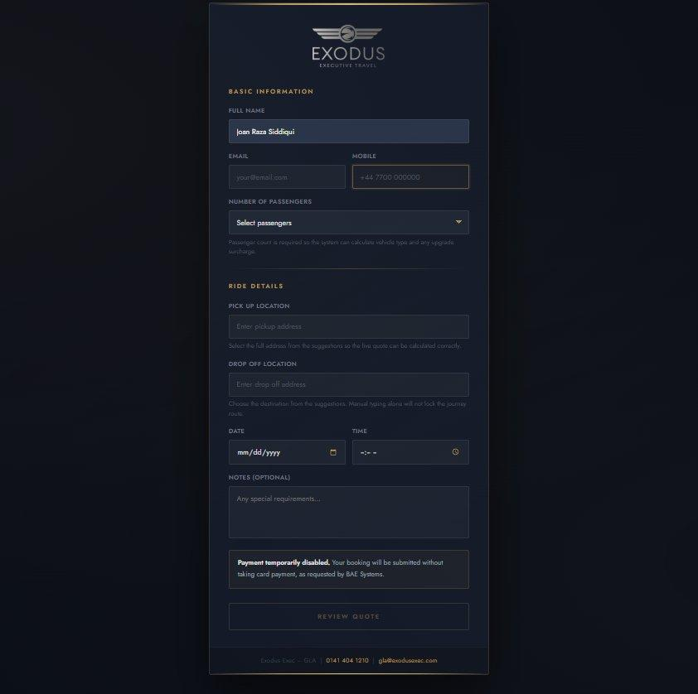

Form Fields
Field | Purpose / Behaviour
Full Name | Free-text input ,pre-populated where available from CRM context
Email | Used for invoice delivery and booking confirmation
Mobile | Stored in booking log; default placeholder +44 7700 000000
Number of Passengers | Dropdown ,drives vehicle-type selection and upgrade surcharge logic
Pick Up Location | Google Places autocomplete (UK-restricted) ,must select from suggestions to lock route
Drop Off Location | Google Places autocomplete (UK-restricted) ,manual typing does not lock journey
Date | Date picker ,used to detect weekends for surcharge application
Time | Time picker ,used to detect midnight window for surcharge application
Notes (Optional) | Free-text for special requirements, flight numbers, accessibility needs

Important: Both pickup and drop-off addresses must be selected from the Google Places autocomplete suggestions. Manual typing alone does not lock the journey route and prevents accurate fare calculation.

4 | Pricing Engine ,Business Logic

All fare calculations run server-side in Flask to prevent client-side manipulation. The frontend receives only the final quoted amount; it cannot alter the price passed to Stripe.

Calculation Flow
1  Receive Form Data | 2  Identify Airport Rule | 3  Calculate Base Fare | 4  Apply Surcharges | 5  Lock Server-Side | 6  Present Quote

Airport Fixed Fare Rules
Glasgow Airport and Edinburgh Airport are identified via Google Place ID / geofencing. When either endpoint matches a known airport Place ID, a fixed fare table is applied instead of mileage-based pricing.

Airport Rule | Behaviour
Glasgow Airport (GLA) | Fixed fares per destination zone ,parking fee added automatically
Edinburgh Airport (EDI) | Fixed fares per destination zone ,parking fee added automatically
Other Routes | Mileage-based pricing via Google Distance Matrix API

Surcharge Rules
Surcharge Type | Trigger Condition
Parking Fee | Automatically added when either journey endpoint is Glasgow or Edinburgh Airport
Midnight Surcharge | Applied when booking time falls within the configured late-night window
Weekend Surcharge | Applied when the booking date falls on Saturday or Sunday
Passenger Upgrade | Higher passenger counts may trigger a vehicle-class upgrade and associated fare adjustment

Mileage-Based Fallback
For all non-airport routes, the fare is calculated using the driving distance returned by the Google Distance Matrix API, multiplied by a per-mile rate configured in the Flask backend. The result is rounded and passed through the surcharge layer before being returned to the frontend.

Booking Log Fields (SharePoint/Excel)
Field | Description
Base Fare | Calculated mileage or fixed airport fare before surcharges
Parking Fee | Airport parking charge (if applicable)
Midnight Surcharge | Late-night uplift (if applicable)
Weekend Surcharge | Weekend uplift (if applicable)
Total Fare | Final amount charged ,matches Stripe payment amount
Distance | Driving distance in miles returned by Distance Matrix API
Airport Rule Trigger | Boolean / label indicating which airport rule fired (if any)
Passenger Count | Number of passengers from form submission
Pickup / Drop-off | Full addresses as resolved by Google Places
Date & Time | Booking date and time as submitted
Customer Name / Email | From form submission ,used for invoice and record

5 | Payment Flow ,Stripe Integration

Stripe is integrated to handle secure card collection. The fare calculated by the Flask backend is locked server-side before the Stripe session is created, ensuring users cannot alter the amount through browser developer tools or API calls.

End-to-End Payment Steps
- User submits booking form ,form data sent via POST to Flask backend.
- Server calculates fare ,applies all pricing rules, surcharges, and airport logic.
- Stripe Checkout session created ,amount set by server; a unique session URL is returned to the browser.
- User completes card payment ,handled entirely on Stripe-hosted or Stripe Elements UI.
- Stripe sends webhook ,payment_intent.succeeded or checkout.session.completed event posted to Flask webhook endpoint.
- Webhook verified ,Flask verifies Stripe signature before processing.
- Booking confirmed ,invoice email sent, SharePoint log entry created.

Security note: The fare amount is never accepted from the frontend or query string. It is always calculated and stored server-side before the Stripe session is created. Stripe webhook signatures are verified using the Stripe-Signature header to prevent spoofed confirmation events.

6 | Automated Email Invoice

Upon a successful Stripe payment confirmation (received via webhook), Flask triggers an automated email to the customer's submitted address. The email serves as both a booking confirmation and a formal invoice.

Email Contents
- Booking reference number
- Customer name, email, and mobile
- Pick-up and drop-off addresses (full resolved addresses)
- Booking date and time
- Number of passengers
- Fare breakdown: base fare, parking, surcharges, total
- Any special notes submitted by the customer
- Exodus Executive Travel contact details (phone and email)

Delivery
Email is dispatched via SMTP using credentials configured in the Flask environment. The email is HTML-formatted to match the Exodus brand. A copy may optionally be sent to the Exodus operations team for internal records.
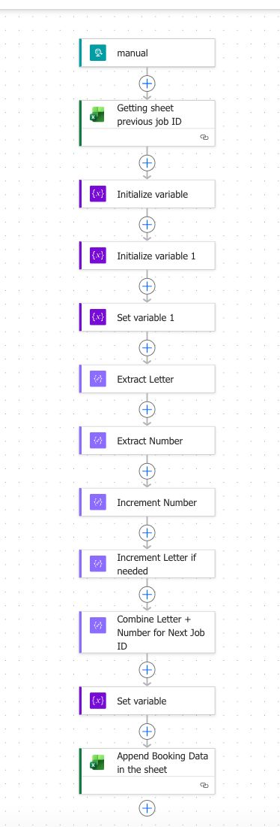

7 | Google Maps Places API Integration

Two Google Maps APIs are used in the booking system ,Places API for address autocomplete on the frontend, and Distance Matrix API for server-side distance calculation.

Places Autocomplete (Frontend)
- Restricted to UK addresses only via the componentRestrictions parameter
- Returns a structured Place object including Place ID, geometry, and formatted address
- Address must be selected from the suggestion list to capture the Place ID ,required for airport detection and accurate routing
- Manual text entry without selecting a suggestion does not lock the journey and triggers a validation warning

Distance Matrix API (Backend)
- Called server-side with the resolved Place IDs or formatted addresses
- Returns driving distance in metres ,converted to miles for fare calculation
- Used only for non-airport routes (mileage-based fallback pricing)
- API key stored securely in Flask environment variables ,never exposed to the frontend

8 | Deployment ,cPanel

The application is deployed on a cPanel shared hosting environment under the Exodus Executive Travel domain.

Deployment Configuration
Item | Detail
Server | cPanel shared hosting
WSGI Entry | Passenger / WSGI adapter ,routes HTTP requests to Flask app
Domain | oss.exodusexec.com
Environment | Python virtual environment with Flask, Stripe SDK, and Google Maps client installed
Config / Secrets | API keys (Google, Stripe secret, SMTP credentials) stored as cPanel environment variables ,not in source code
Static Assets | CSS, JavaScript, logo served directly via cPanel's static file handler

9 | Challenges & Solutions

Challenge: Preventing client-side fare manipulation before Stripe payment
Solution: All fare calculation is performed exclusively server-side in Flask. The frontend displays the estimated fare for UX purposes only. The amount passed to Stripe is always the server-calculated value ,users cannot alter it via the browser or API calls.
Challenge: Accurately detecting Glasgow and Edinburgh Airport endpoints
Solution: Google Places API returns a unique Place ID for each location. The backend maintains a lookup table of known airport Place IDs. When a submitted address matches a known airport Place ID, the fixed fare rule fires automatically ,no string matching required.
Challenge: Ensuring the correct address is used for routing (not raw text input)
Solution: Frontend JavaScript validates that the user selected an address from the Places autocomplete list before allowing form submission. The Place ID ,not the typed text ,is submitted to the backend, guaranteeing the Distance Matrix API receives a resolvable identifier.
Challenge: Handling multiple surcharge conditions that may apply simultaneously
Solution: The Flask pricing engine applies surcharges sequentially and independently ,parking, midnight, and weekend charges are each evaluated and added to the base fare as separate line items, ensuring no condition masks another and the full breakdown is logged.
Challenge: Reliably confirming payment without relying on redirect URLs
Solution: Rather than trusting a post-payment redirect (which can be interrupted), booking confirmation is triggered exclusively by the Stripe webhook. Webhook payloads are verified using Stripe's signature header before any downstream actions (email, SharePoint log) are executed.

10 | System Architecture Summary

Layer | Role
User Browser | HTML/CSS/JS booking form ,Google Places autocomplete, real-time fare preview
Google Maps API | Places autocomplete (UK) + Distance Matrix for mileage calculation
Flask Backend | Fare engine, airport rule evaluation, Stripe session creation, webhook handler
Stripe | Secure payment collection; webhook confirms successful transactions
SMTP / Email | Automated HTML invoice dispatched on successful payment
SharePoint / Excel | Structured booking log: fare breakdown, surcharges, distance, airport trigger
cPanel Hosting | WSGI/Passenger deployment ,serves Flask app and static assets

Exodus Exec ,SLA | 0141 404 1210 | gla@exodusexec.com

